

**SUSTAINABLE OUTREACH AND UNIVERSIAL LEADERSHIP LIMITED (SOUL)**

This document contains information that is proprietary and confidential to SUSTAINABLE OUTREACH AND UNIVERSIAL LEADERSHIP (SOUL) LIMITED, Odisha, India and it shall not be disclosed outside and shall not be transmitted, or duplicated, used in whole or in part for any purpose other than its intended purpose. Any use or disclosure in whole or in part of this information without written permission SOUL Limited is prohibited.



ERP SCOPE DOCUMENT

BEPC PMO Application

**Statement of confidentiality**

This document contains information that is proprietary and confidential to SUSTAINABLE OUTREACH AND UNIVERSIAL LEADERSHIP (SOUL) LIMITED, India and it shall not be disclosed outside and shall not be transmitted, or duplicated, used in whole or in part for any purpose other than its intended purpose. Any use or disclosure in whole or in part of this information without written permission SOUL Limited is prohibited.

**Table of Contents**

1 INTRODUCTION 5

2 Introducing SOUL Limited 6

3 EduLead ERP– Module wise High Level Scope 7

4 BEPC PMO Application 10

4.1 Background 10

4.2 Module: Survey Setup and Data Capture 13

4.3 Module: Survey Initiation 14

4.4 Module: Survey Run 17

4.5 Module: Survey Run 21

4.6 Module: Quarterly Billing Management 25

4.6.1 Helpdesk Management 26

4.6.2 Teachers training Activities ** Not applicable for development team? 26

4.6.3 Theft Case monitoring 26

4.6.4 Students database management 27

4.6.5 Teachers data base management 27

4.6.6 Internet Data Management 28

4.6.7 Electricity Consumption 28

4.6.8 Training Content Management 28

4.6.9 Equipment Uptime 28

4.6.10 Customer feedback management 29

4.6.11 Centralized monitoring management 29

4.6.12 Scheduled Reports: 29

● Monthly Report Management 29

● Quarterly Report Management 29

4.6.13 Quarterly Billing Management 29

# INTRODUCTION

Following document will provide the high-level scope for BEPC project management to help the site team manage survey and infrastructure setup and subsequent billing,

# Introducing SOUL Limited

Sustainable Outreach and Universal Leadership Limited (SOUL), with its headquarter in Bhubaneswar advises its clients on strategy for business transformation, focused on sustainability through delivery process realignment, organization restructuring, skill development, smart negotiation & contracting, and digitalization, to achieve improvements in operational efficiency, capital productivity and workplace harmony. We also support our clients implement such strategies and help them achieve the desired outcomes. ERP software for various domains has been developed as part of overall Digital Transformation of an organization.

SOUL Limited is a subsidiary of KIIT (Kalinga Institute of Information Technology), one of the top Private Universities in India. A team of professionals having extensive experience in major IT services and top notch consulting organisations leads SOUL. Some key points about services offered by SOUL on Technology and business domains is given below.

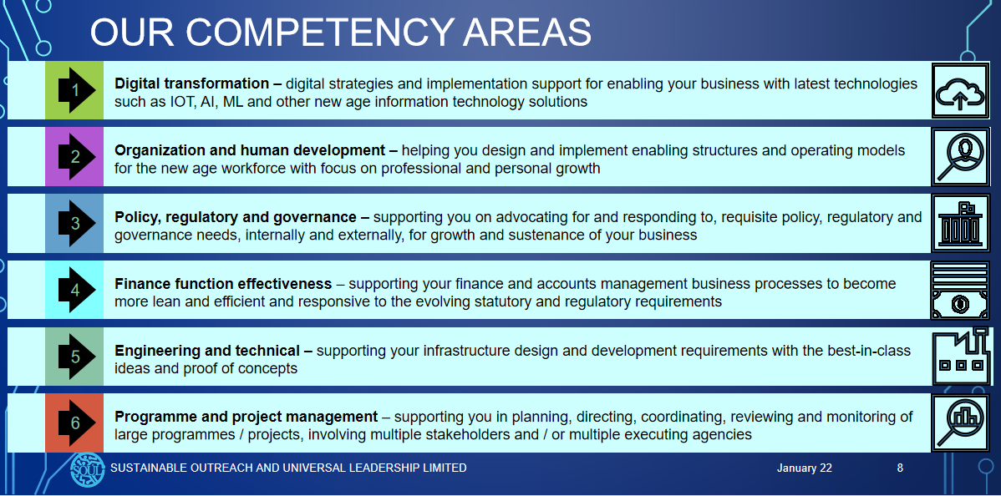

# EduLead ERP– Module wise High Level Scope

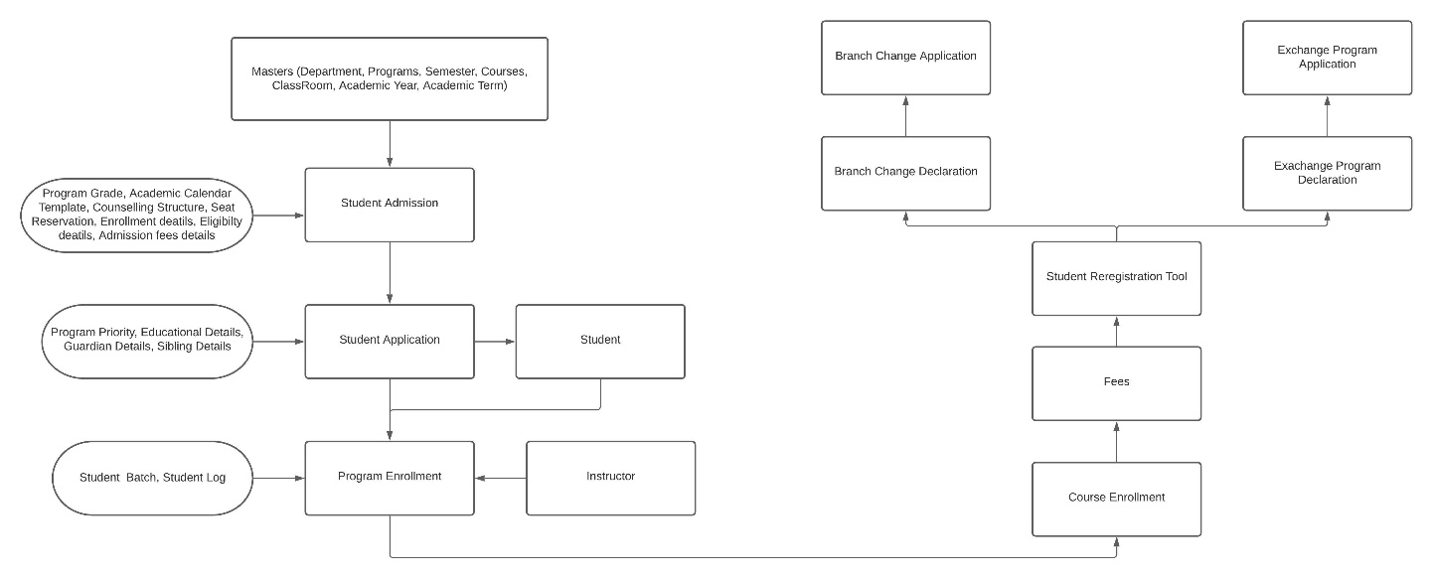

Advances in information technology have redefined the way educational institutions handle their operations. The replacement of the older legacy systems with centralized ERP brings quick and quantifiable improvement in the administration process. The software includes a set of tools that modernizes the campus along with upgrading the planning and management of processes related to student enrolment, lecture sessions, courses, academics, examination, continuous evaluation, customer/client support, etc.

An education ERP system automates and streamlines all the processes functioning within the boundaries of the institution to significantly improve the effectiveness of allocating and operating academic resources better.

Educational institutions play a key role in shaping the future of a child not to mention a nation. Every step of education whether it’s K12 or higher education plays a critical role in the cognitive and academic development of their pupils. Therefore, the educational institution deserves the best tools for their management practices, carrying out their administrative and academic processes in the most efficient and effective manner. It is important for them to keep themselves abreast with the modern technology and management tools for constant improvement in terms of knowledge implementation, their well-being and most importantly a strategic framework of child development.

Unlike previous days, now education institutions are filled with endless data, accumulated with tons of paperwork related to students, teachers, management, staff, parents and whatnot. Education ERP in education institutions provides all the support that an educational institution needs to manage these tasks, make their world easy, efficient and effective. It helps them to fulfil their ultimate objectives of the core development of students by providing them the luxury of time.

It is the operational requirement of the **College/School/University** to provide state-of-the-art information systems and Electronic Communication Services (via Internet and intranet) to enhance the workflow and carry out the administrative activities of the educational institution effectively and efficiently. For this purpose, any education institution implements an ERP.

Everyone with access to the computer and the internal network can access the ERP. This includes the use of all software features with necessary authorization.

# BEPC PMO Application

## Background

* This system is designed to augment the capabilities of smart class project management office team during roll out of smart class setup for each school across district in Bihar state.
* The concerned entities are individual schools and system will be used to provide MIS reports and daily progress status to relevant teachers and Bihar education department staff who may demand report or status on a need basis.
* The system will contain the necessary legal proof of process execution like files/videos/images etc. and transaction and master data such that billing can be done per Site by Soul on time. In case of issues wrt service delivery and complaints etc. same data can be used to handle complaints/legal enquiry etc..

High level Process Flow

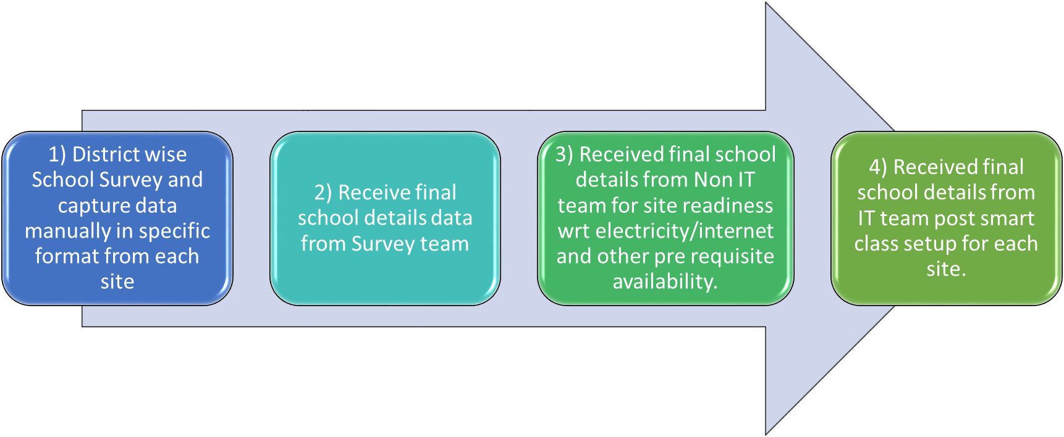

Workflow for Survey data capture analysis setup

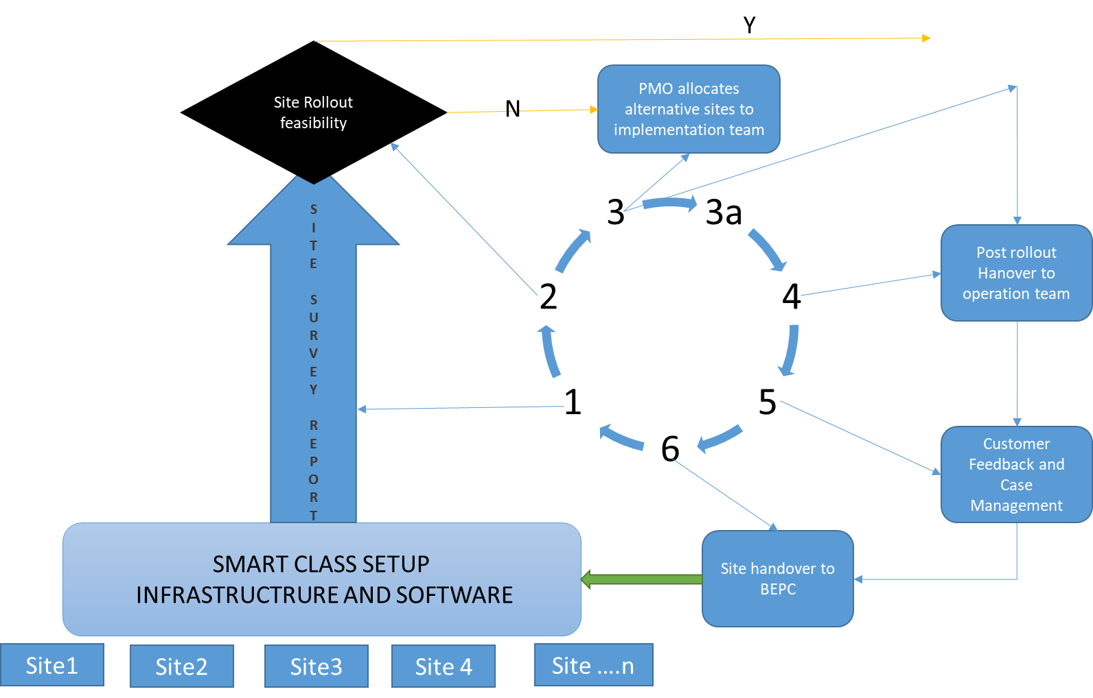

User Hierarchy

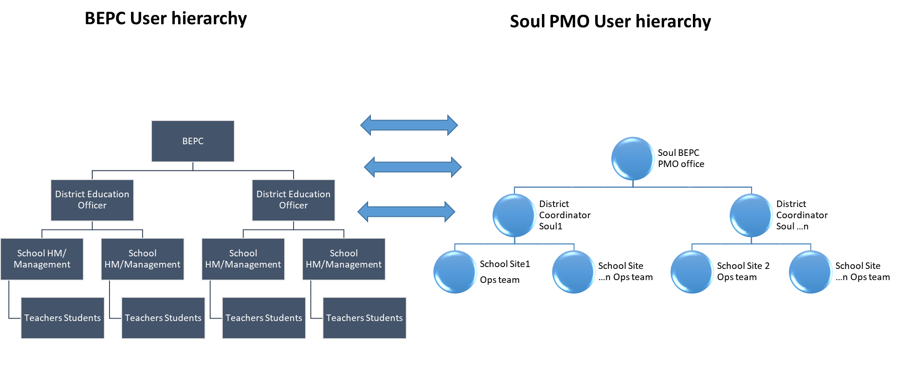

## Module: Survey Setup and Data Capture

All the data uploaded followed by image of:-

* Survey format
* Location(Longitude/ latitude)
* Room Pic with Setup
* School Pic

|  |  |  |  |  |
| --- | --- | --- | --- | --- |
| **Survey Management** | **Category (Purpose)** | **Sub Category (Features)** | **Business Process** | **Exception/Validations** |
|  | Master Data | CRUD application (create/read/delete/update) | Maintain survey Questionnaire (Mandatory and optional questions and expected answers/guidelines) |  |
|  | Master Data | CRUD application (create/read/delete/update) | Maintain Survey Questionnaire analysis Screen |  |
|  | Transaction Screen | CRUD application (create/read/delete/update) | Maintain Survey related attachments/pictures/excel documents |  |
|  | Report | View/Export/Print Report | Survey SLA reporting module (Survey completion status, Time to Complete ,Survey ID, Survey Planned Start and End Time versus Actual Start and End Time). |  |
|  | Report | View/Export/Print Report | District Team wise survey status and calendar view for planning. |  |
|  | Master Data | CRUD application (create/read/delete/update) | Maintain list of users for survey, Level 1 and Level2 approvers with email id. |  |
|  | Transactions Screen | CRUD application (Create/Read/Delete/Update) | Maintain Survey ID and team mapping and add miscellaneous data. |  |

## Module: Survey Initiation

## 

Pre Processing: Survey is setup.

Processing: Survey data is received from Survey team.

Post-Processing: Workflow is triggered for Non IT survey

All the data uploaded followed by image of:-

* Delivery and installation report
* Location(Longitude/ latitude)
* Room Pic after infra work
* Earthing Pic



|  |  |  |  |  |
| --- | --- | --- | --- | --- |
| **Survey Management**  **Processing** | **Category (Purpose)** | **Sub Category (Features)** | **Business Process** | **Exception/Validations** |
|  | Workflow Transaction Screen | CRUD application (create/read/delete/update) | Workflow Form/ui setup |  |
|  | Workflow Transaction Screen | CRUD application (create/read/delete/update) | Workflow Transition setup |  |
|  | Workflow Transaction Screen | CRUD application (create/read/delete/update) | Workflow attachment/document setup via related doctype | Mandatory document and document type check |
|  | Master Data | CRUD application (create/read/delete/update) | Workflow roles permission setup. |  |
|  | Workflow Transaction Screen | CRUD application (create/read/delete/update) | Workflow actions setup |  |
|  | Master Data | CRUD application (create/read/delete/update) | Access management setup & approver onboarding |  |
|  | Workflow Transaction Screen | CRUD application (create/read/delete/update) | Followup screen for SNR site | Generate an email for each followup actions |
|  | Workflow Transaction Screen | CRUD application (create/read/delete/update)  Workflow Approval (approve/reject/pend etc…) | Level 1 Verification | Edit option closed for Survey team |
|  | Workflow Transaction Screen | CRUD application (create/read/delete/update)  Workflow Approval (approve/reject/pend etc…) | Level 2 Verification | Edit option closed for level one team |
|  | Workflow Transaction Screen | CRUD application (create/read/delete/update)  Workflow Approval (approve/reject/pend etc…) | Non IT Site Survey Freeze and final approval | Edit option closed for level two team |
|  | Data Handover | Backend Process | Data handover to Implementation team. |  |

## Module: Survey Run

## 

Pre-Processing: Survey data is received from Survey team.

Processing: Non-IT Workflow is triggered to study Non IT setup and analyse data.

Post Processing: Data handover to IT team



All the data uploaded followed by image of:-

* Delivery and installation report
* Location(Longitude/ latitude)
* Room Pic after infra work
* Earthing Pic

|  |  |  |  |  |
| --- | --- | --- | --- | --- |
| **Survey Management** | **Category (Purpose)** | **Sub Category (Features)** | **Business Process** | **Exception/Validations** |
|  | Master Data | CRUD application (create/read/delete/update) | Maintain survey Questionnaire (Mandatory and optional questions and expected answers/guidelines) |  |
|  | Master Data | CRUD application (create/read/delete/update) | Maintain Survey Questionnaire analysis Screen |  |
|  | Transaction Screen | CRUD application (create/read/delete/update) | Maintain Survey related attachments/pictures/excel documents |  |
|  | Report | View/Export/Print Report | Survey SLA reporting module (Survey completion status, Time to Complete ,Survey ID, Survey Planned Start and End Time versus Actual Start and End Time). |  |
|  | Report | View/Export/Print Report | District Team wise survey status and calendar view for planning. |  |
|  | Master Data | CRUD application (create/read/delete/update) | Maintain list of users for survey, Level 1 and Level2 approvers with email id. |  |
|  | Transactions Screen | CRUD application (Create/Read/Delete/Update) | Maintain Survey ID and team mapping and add miscellaneous data. |  |
|  | Workflow Transaction Screen | CRUD application (create/read/delete/update) | Follow-up screen for SNR site | Generate an email for each follow-up actions |
|  | Workflow Transaction Screen | CRUD application (create/read/delete/update)  Workflow Approval (approve/reject/pend etc…) | Level 1 Verification | Edit option closed for Survey team |
|  | Workflow Transaction Screen | CRUD application (create/read/delete/update)  Workflow Approval (approve/reject/pend etc…) | Level 2 Verification | Edit option closed for level one team |
|  | Workflow Transaction Screen | CRUD application (create/read/delete/update)  Workflow Approval (approve/reject/pend etc…) | Non IT Site Survey Freeze and final approval | Edit option closed for level two team |

## 

## Module: Survey Run2

Pre-Processing: School Survey data is received from Survey team.

Processing: IT Workflow is triggered to study IT setup and analyse data.

Post Processing: Data is handover to operations team.



|  |  |  |  |  |
| --- | --- | --- | --- | --- |
| **Survey Management** | **Category (Purpose)** | **Sub Category (Features)** | **Business Process** | **Exception/Validations** |
|  | Master Data | CRUD application (create/read/delete/update) | Maintain survey Questionnaire (Mandatory and optional questions and expected answers/guidelines) |  |
|  | Master Data | CRUD application (create/read/delete/update) | Maintain Survey Questionnaire analysis Screen |  |
|  | Transaction Screen | CRUD application (create/read/delete/update) | Maintain Survey related attachments/pictures/excel documents |  |
|  | Report | View/Export/Print Report | Survey SLA reporting module (Survey completion status, Time to Complete ,Survey ID, Survey Planned Start and End Time versus Actual Start and End Time). |  |
|  | Report | View/Export/Print Report | District Team wise survey status and calendar view for planning. |  |
|  | Master Data | CRUD application (create/read/delete/update) | Maintain list of users for survey, Level 1 and Level2 approvers with email id. |  |
|  | Transactions Screen | CRUD application (Create/Read/Delete/Update) | Maintain Survey ID and team mapping and add miscellaneous data. |  |
|  | Workflow Transaction Screen | CRUD application (create/read/delete/update) | Follow-up screen for SNR site | Generate an email for each followup actions |
|  | Workflow Transaction Screen | CRUD application (create/read/delete/update)  Workflow Approval (approve/reject/pend etc…) | Level 1 Verification | Edit option closed for Survey team |
|  | Workflow Transaction Screen | CRUD application (create/read/delete/update)  Workflow Approval (approve/reject/pend etc…) | Level 2 Verification | Edit option closed for level one team |

## Module: Quarterly Billing Management

This module will be operational once Survey data is received, analysed by the team, approved, and frezed.. The smart class team to perform roll out, manage billing once the site is setup, and live will use the data. Data collected on demand by BEPC and on scheduled interval will be data source for this module.

Additionally we need to collect data from miscellaneous systems like electricity consumption, equipment uptime etc. to know the status of implementation.

Billing Data

Site Operational Data

* Electricity meter reading
* Equipment Uptime
* Student Data
* Teachers Data.

Help desk team

PMO Team

BEPC

Reports

Web Application

Customer Feedback Data

Frozen and Approved Survey Data

BEPC Database

### Module Helpdesk Management

Help desk management with SLA and SLA breach report with alarm/notification/email facility.

* Manage customers
* Project management with basic issue tracking
* Issue Creation
* Service level agreement
* Record warranty claims
* Maintenance visit
* Maintenance schedule
* Accounting
* Budgeting
* Invoice Generation
* Billing per site

### Module Operational Management

### Teachers training Activities ** Not applicable for development team?

Teacher training activity: Calendar like tool to setup training program/update status/archive training etc.

### Theft Case monitoring

Theft case monitoring option will be a case management/form with facility to upload police report/FIR, insurance intimation and approval, post approval and insurance claim settlement so that smart class infrastructure can be replaced once insurance claim is settled.

### Students database management

Master data management with student and teachers and report to show growth per quarter/yearly basis.

### Teachers data base management

Master data management with student and teachers and report to show growth per quarter/yearly basis

### Internet Data Management

We assume interest data monitoring will be a screenshot of data consumption and no real time integration needs to be built to ISP like jio/ voda phone/ airtel /bsnl etc. Monitoring of internet data consumption and address any anomaly/concerns.

The screenshot of consumption and consumption reading monthly needs to be captured per site so that reports can be run at district level.

### Electricity Consumption

Electricity consumption needs to be checked on regular basis and picture of meter reading for each site needs to be uploaded on monthly basis and reading needs to be captured on the system for record purposes.

The screenshot of consumption and consumption reading monthly needs to be captured per site so that reports can be run at district level.

### Training Content Management

Training content usage for list of trainings enabled per site needs to be monitored and uploaded

The screenshot of consumption and consumption reading monthly needs to be captured per site so that reports can be run at district level.

### Equipment Uptime

Equipment uptime reports needs to be captured from a centralized application by tracking each hardware Mac-ID and uptime. In case an equipment is not operational or not switched on due to holiday/unplanned outage like strike/bandh/electricity power cut etc… same should be captured with date/time with appropriate status code such that reports can be run on need basis.

The screenshot of consumption and consumption reading monthly needs to be captured per site so that reports can be run at district level.

### Customer feedback management

The operation team will collect site usage and smart class setup related feedback in regular basis and upload to a centralized system for analysis and corrective action by Soul PMO team.

### Centralized monitoring management

All the data will be monitored through centralized monitoring management (We will use standard database infrastructure and health monitoring. For process monitoring, we will use reports/alert mechanism.

### Module Scheduled Reports:

### Monthly Report Management

Monthly report format to be finalized.

### Quarterly Report Management

Monthly report format to be finalized.

### Module Quarterly Billing Management

* Invoice/Billing creation
* Billing dispute management & Resolution
* Reports on Billed Actual to Realized
* Reports on Dispute wrt task completion and management
* Maintenance of status code and description for Invoice generation.